OS SKILL
SKILL-8
To Detect Variable References, Expand Values, Handle Undefined Variables, Update Tokens, Support Nested Variables, Test Expansion Logic.

To Identify Built-ins, Create Dispatch Table, Execute In-Process Commands, Handle Invalid Commands, Maintain State, Test Dispatch Logic.

variable_expand.c

#include <stdio.h>
#include <stdlib.h>
#include <string.h>
#include <ctype.h>
#define SIZE 4096
void expand(const char *input, char *output, int depth) {
int i = 0, j = 0;
if (depth > 10) {
output[0] = '\0';
return;
}
while (input[i] != '\0' && j < SIZE - 1) {
if (input[i] == '$') {
char name[256];
char value[SIZE];
int k = 0;
i++;
if (input[i] == '{') {
i++;
while (input[i] != '\0' &&
input[i] != '}' &&
k < 255) {
name[k++] = input[i++];
}
name[k] = '\0';
if (input[i] == '}')
i++;
} else {
while ((isalnum((unsigned char)input[i]) ||
input[i] == '_') && k < 255) {
name[k++] = input[i++];
}
name[k] = '\0';
}
if (k == 0) {
output[j++] = '$';
continue;
}

const char *env = getenv(name);

if (env != NULL) {
expand(env, value, depth + 1);

for (int x = 0;
value[x] != '\0' && j < SIZE - 1;
x++) {
output[j++] = value[x];
}
}
} else {
output[j++] = input[i++];
}
}
output[j] = '\0';
}
int main() {
char input[SIZE];
char output[SIZE];
printf("Enter a string: ");
if (fgets(input, sizeof(input), stdin) == NULL)
return 1;
input[strcspn(input, "\n")] = '\0';
expand(input, output, 0);
printf("Expanded string: %s\n", output);
return 0;
}
OUTPUT
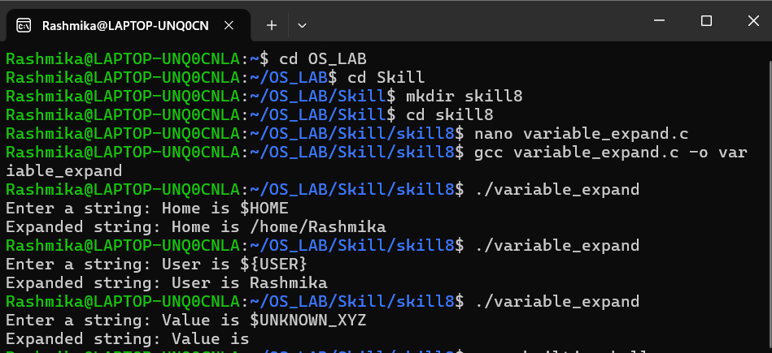
builtin_shell.c

#include <stdio.h>
#include <stdlib.h>
#include <string.h>
#include <unistd.h>
#include <limits.h>
#define MAX_INPUT 256
#define MAX_ARGS 10
int running = 1;
int builtin_cd(char **args) {
const char *path = args[1];
if (path == NULL)
path = getenv("HOME");
if (path == NULL) {
printf("cd: HOME not set\n");
return 1;
}
if (chdir(path) != 0) {
perror("cd");
return 1;
}
return 0;
}
int builtin_pwd(char **args) {
char cwd[PATH_MAX];
if (getcwd(cwd, sizeof(cwd)) != NULL)
printf("%s\n", cwd);
else
perror("pwd");
return 0;
}
int builtin_help(char **args) {
printf("Built-in commands:\n");
printf("cd [directory] - Change directory\n");
printf("pwd - Print current directory\n");
printf("help - Display help\n");
printf("exit - Exit the shell\n");
return 0;
}
int builtin_exit(char **args) {
running = 0;
return 0;
}
struct Command {
char *name;
int (*function)(char **);
};
struct Command commands[] = {
{"cd", builtin_cd},
{"pwd", builtin_pwd},
{"help", builtin_help},
{"exit", builtin_exit}
};
#define COMMAND_COUNT (sizeof(commands) / sizeof(commands[0]))
int execute_builtin(char **args) {
if (args[0] == NULL)
return 0;
for (int i = 0; i < COMMAND_COUNT; i++) {
if (strcmp(args[0], commands[i].name) == 0)
return commands[i].function(args);
}
printf("Invalid built-in command: %s\n", args[0]);
return 1;
}
int main() {
char input[MAX_INPUT];
while (running) {
printf("mini-shell> ");
fflush(stdout);
if (fgets(input, sizeof(input), stdin) == NULL)
break;
input[strcspn(input, "\n")] = '\0';
char *args[MAX_ARGS];
int count = 0;
char *token = strtok(input, " \t");
while (token != NULL && count < MAX_ARGS - 1) {
args[count++] = token;
token = strtok(NULL, " \t");
}
args[count] = NULL;
execute_builtin(args);
}
printf("Shell terminated.\n");
return 0;
}
OUTPUT
